**RIVER DISCHARGE ANALYSIS OF DANUBE AND ISAR**

Abhijeet Parida and Nikhil Agarwal

Technische Universität München

Abstract

[The abstract should be one paragraph of between 150 and 250 words. It is not indented. Section titles, such as the word Abstract above, are not considered headings so they don’t use bold heading format. Instead, use the Section Title style. This style automatically starts your section on a new page, so you don’t have to add page breaks. Note that all of the styles for this template are available on the Home tab of the ribbon, in the Styles gallery.]

Keywords: [Click here to add keywords.]

**RIVER DISCHARGE ANALYSIS OF DANUBE AND ISAR**

For better prevention of flood events, thus planning protection measures and mitigation actions it is important to analyze the discharge of rivers and the regarding water height, e.g. in order to estimate how likely a critical water height could be exceeded.You are given daily measurements for the discharge of the two rivers Isar and Danube from 1925/11/01 to 2017/05/21 as they can be downloaded from Bayerisches Landesamt für Umwelt (www.gkd.bayern.de). The measurements are given for the gauge stations Plattling (Isar) and Hofkirchen (Danube). The estuarial area where the Isar River enters the Danube River lies in the commune Moos south of Deggendorf and east of Plattling.

# 1. Introduction

## 1.1.Descriptive Statistical Analysis

Descriptive statistics include the numbers, tables, charts, and graphs used to describe, organize, summarize, and present raw data. Descriptive statistics are most often used to examine[1]:

* **Central tendency** (location) of data, i.e. where data tend to fall, as measured by the mean, median, and mode.
* **Dispersion** (variability) of data, i.e. how spread out data are, as measured by the variance and its square root, the standard deviation.

## 1.1 Central Tendency

**Measures of Central Tendency** indicate the middle and commonly occurring points in a data set. **Mean** is the average, the most common measure of central tendency. The mean may not always be the best measure of central tendency, especially if data are skewed. **Median** is the value in the middle of the data set when the measurements are arranged in order of the magnitude. **Mode** is the value occurring most often in the data.

The Table Tab 1-3. Shows a comparision of the central tendencies of both rivers.

|  |  |  |  |
| --- | --- | --- | --- |
| River | Mean  Discharge  (Mean) | Mean  Discharge  (Max) | Mean  Discharge  (Min) |
| Danube |  |  |  |
| Isar |  |  |  |

Tab 1. Means of various discharges of Danube and Isar

|  |  |  |  |
| --- | --- | --- | --- |
| River | Mode  Discharge  (Mean) | Mode  Discharge  (Max) | Mode  Discharge  (Min) |
| Danube |  |  |  |
| Isar |  |  |  |

Tab 2. Modes of various discharges of Danube and Isar

|  |  |  |  |
| --- | --- | --- | --- |
| River | Median  Discharge  (Mean) | Median  Discharge  (Max) | Median  Discharge  (Min) |
| Danube |  |  |  |
| Isar |  |  |  |

Tab 3. Means of various discharges of Danube and Isar

## 1.2 Dispersion

**Measures of Dispersion** indicate how spread out the data are around the mean. **Variance** is expressed as the sum of the squares of the differences between each observation and the mean, which quantity is then

divided by the sample size . **Standard deviation** is expressed as the positive square root of the variance. The standard deviation is used when expressing dispersion in the same units as the original measurements.

The Table Tab 4-5. Shows a comparision of the dispersions of both rivers.

|  |  |  |  |
| --- | --- | --- | --- |
| River | variance  Discharge  (Mean) | variance  Discharge  (Max) | variance  Discharge  (Min) |
| Danube |  |  |  |
| Isar |  |  |  |

Tab 4. Means of various discharges of Danube and Isar

|  |  |  |  |
| --- | --- | --- | --- |
| River | std. dev  Discharge  (Mean) | std. dev  Discharge  (Max) | std. dev  Discharge  (Min) |
| Danube |  |  |  |
| Isar |  |  |  |

Tab 5. Modes of various discharges of Danube and Isar

[To add a table of contents (TOC), apply the appropriate heading style to just the heading text at the start of a paragraph and it will show up in your TOC. To do this, select the text for your heading. Then, on the Home tab, in the Styles gallery, click the style you need.]

## 2.1 Probability Distribution

The probability distribution is a description of a random phenomenon in terms of the probabilities of events. Examples of random phenomena can include the results of an experiment or survey. A probability distribution is defined in terms of an underlying sample space, which is the set of all possible outcomes of the random phenomenon being observed. Every random variable has a probability distribution, which specifies the probability that its value falls in any given interval.

## 2.2 Quantile-Quantile Plot (Probability Plot)

The quantile function is the inverse CDF, which returns the value x such that the cumulative probability at x is q.

A probability plot (Q-Q plot) is a graphical technique for comparing two data sets, either two sets of empirical observations, one empirical set against a theoretical set, or (more rarely) two theoretical sets against each other.

### 2.2.1 Difference in means, all else constant.

A pure difference in means looks like a constant offset from the identity line in the QQ plot. If the QQ plot is always below the identity line, that means that the variable plotted on X is larger than Y by a constant offset.

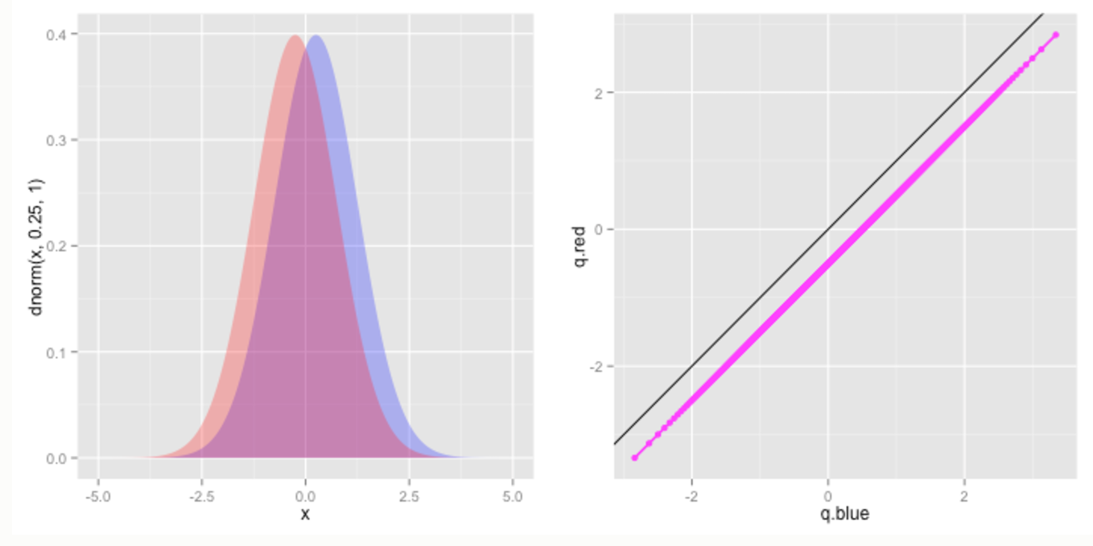

### 2.2.2 Difference in variance, all else constant.

A pure difference in variance will manifest as a slope that differs from 1. For instance, if X has the same mean, but higher variance than Y, then the upper quantiles (those close to 1) of X will be larger than those of Y (so the QQ plot will be below the identity line at the right of the plot), and the lower quantiles (those near 0) of X will be smaller than those of Y (so the QQ points will be above the identity line at the left of the plot). Consequently, if X has a larger variance than Y, then the QQ plot will have a slope less than 1; a slope greater than 1 indicates the opposite – that Y has a larger variance than X.

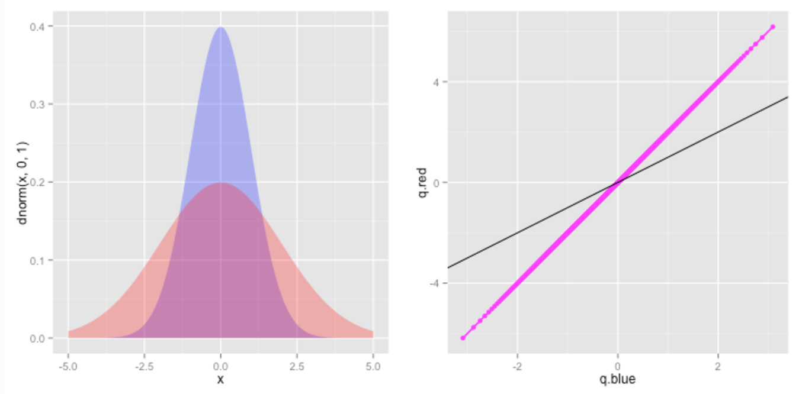

### 2.2.3 Difference in skew, all else constant.

A difference in skew, with constant mean and variance means that one distribution will have a heavier tail in one direction than the other. Thus, if X has a more positive skew than Y, then upper quantiles of X will be larger than those of Y, and the lower quantiles of Y will be smaller than those of X, but the middle quantiles of X will be roughly matched to those of Y. Consequently, we will get a curved shape: the qq plot will be below the identity line at the left and right of the plot, and at or above the identity line in the middle – a shape that is concave down. If X has a more negative skew, we will get a curved shape that is concave up.

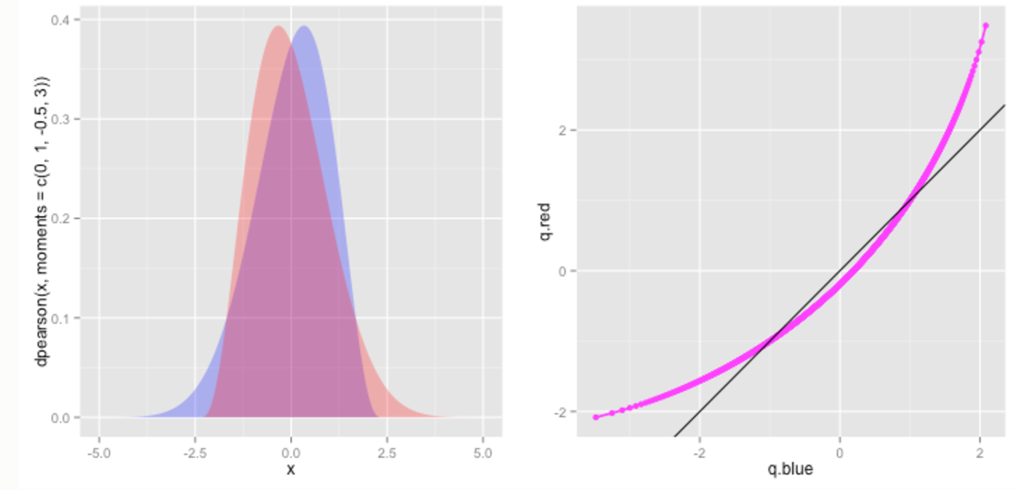

### 2.2.4 Difference in kurtosis, all else constant

A difference in kurtosis with constant skew, variance, and mean would make the higher kurtosis distribution have heavier tails at the extremes, but lighter tails at less extreme points. Thus the QQ plot will look like a quadratic squiggle. If X has a greater kurtosis than Y, then its the extreme positive quantiles will be larger, and its extreme negative quantiles will be smaller than Y, thus the left and right ends of the qq plot will be above and below the identity line, respectively, but this pattern will reverse near the middle. (And the converse will be true if X has a lower kurtosis than Y.)

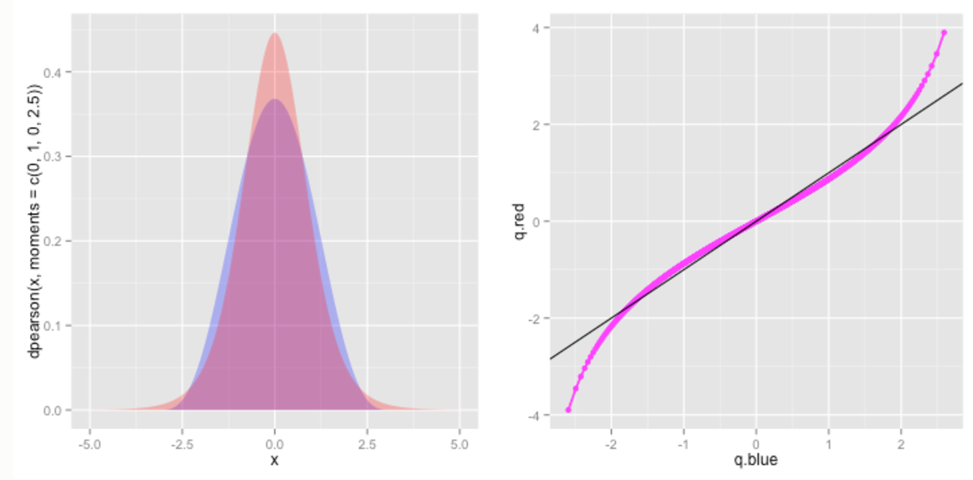

## 2.3 Log-logistic Distribution

Log-logistic distribution (known as the Fisk distribution in economics) is a continuous probability distribution for a non-negative random variable. It is used in survival analysis as a parametric model for events whose rate increases initially and decreases later, for example mortality rate from cancer following diagnosis or treatment. It has also been used in hydrology to model stream flow and precipitation, in economics as a simple model of the distribution of wealth or income, and in networking to model the transmission times of data considering both the network and the software.

The log-logistic distribution is the probability distribution of a random variable whose logarithm has a logistic distribution. It is similar in shape to the log-normal distribution but has heavier tails. Unlike the log-normal, its cumulative distribution function can be written in closed form.

Probability density functions: Log-logistic Distribution

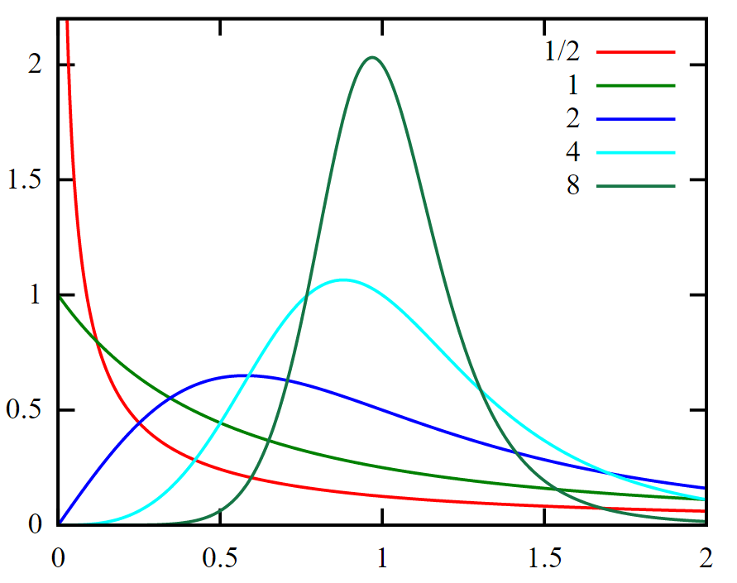

α=1, values of {\displaystyle \beta }β as shown in legend

Cumulative distribution function: Log-logisctic Distribution

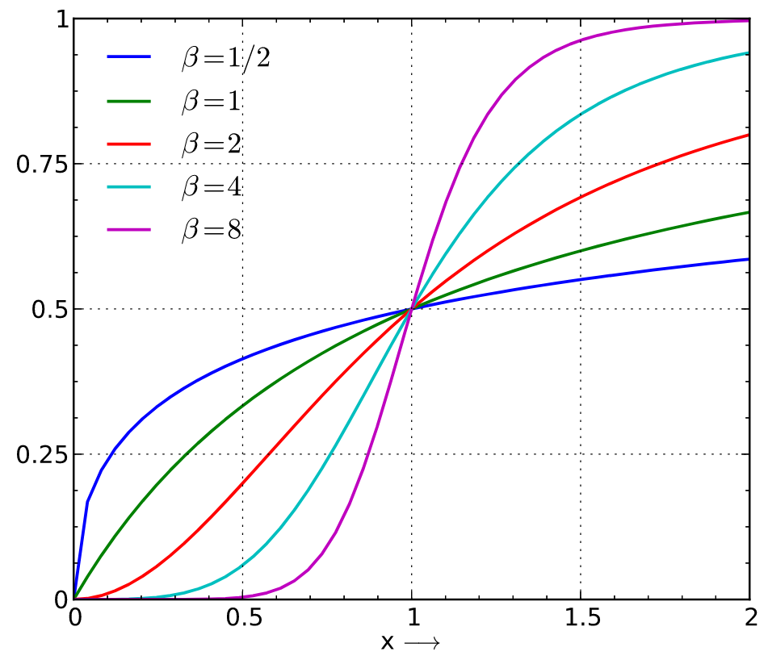

α=1, values of {\displaystyle \beta }β as shown in legend

The parameter α>0 is a scale parameter and is also the median of the distribution. The parameter β>0 is a shape parameter. The distribution is unimodal when β>1 and its dispersion decreases as β increases.

The probability density function is

$$f(x;α,β)=\frac{(β/α)(x/α)^{β-1}}{{(1+(x/α)^{β})}^{2}}$$

The quantile function (inverse cumulative distribution function) is :

$$F^{-1}(p;α,β)=α{(\frac{p}{1-p})}^{1/β}$$

### [Heading 3].

[Include a period at the end of a run-in heading. Note that you can include consecutive paragraphs with their own headings, where appropriate.]

#### [Heading 4].

[When using headings, don’t skip levels. If you need a heading 3, 4, or 5 with no text following it before the next heading, just add a period at the end of the heading and then start a new paragraph for the subheading and its text.] (Last Name, Year)

##### [Heading 5].

[Like all sections of your paper, references start on their own page. The references page that follows is created using the Citations & Bibliography feature, available on the References tab. This feature includes a style option that formats your references for APA 6th Edition. You can also use this feature to add in-text citations that are linked to your source, such as those shown at the end of this paragraph and the preceding paragraph. To customize a citation, right-click it and then click Edit Citation.] (Last Name, Year)

# 2. Approach

## Task 1

Measures of Central Tendency indicate the middle and commonly occurring points in a data set. Mean

## 2.2 Identifying Distribution

### 2.2.1 Fitting Distribution

In Matlab, pd = fitdist(x, distname) creates a probability distribution object by fitting the distribution specified by distname to the data in column vector x.

In Matlab, probplot(dist,y) creates a probability plot for the distribution specified by dist, using the sample data in y.

### To visualize the fit of the specified distribution, the probability plot is examined for how closely the data points follow the fitted distribution line. If the specified theoretical distribution is a good fit, the points fall closely along the straight line.

### 2.2.2 Plotting PDF

The histogram of the data can be plotted in matlab using, hist(x, nbins) that creates a histogram bar chart of the elements in vector x. The elements in x are sorted into equally spaced bins along the x-axis between the minimum and maximum values of x. hist displays bins as rectangles, such that the height of each rectangle indicates the number of elements in the bin.

In Matlab, y = pdf(pd, x) returns the probability density function of the probability distribution object, pd, evaluated at the values in x.

The area under the fitted distribution is scaled with the area under the histogram.

$$.$$

# 3. Results

From the data analysis, it is found that the annually the maximum river height at Platting occurs most likely in the months of June to August based on the analyses during the period 1971 to 2016.

Based on the comparison of Probability distribution plot superimposed on the histogram and also from the Quantile-Quantile plot we found that, log logistic distribution is better representative of the data for Annual Mean and Annual Maximum Discharge of Isar measured at Plattling.

# 4. Conclusion

Distribution of Annual Mean Discharge of Isar measured at Plattling is Log-logistic distribution.

References

Last Name, F. M. (Year). Article Title. *Journal Title*, Pages From - To.

Last Name, F. M. (Year). *Book Title.* City Name: Publisher Name.

Footnotes

1[Add footnotes, if any, on their own page following references. For APA formatting requirements, it’s easy to just type your own footnote references and notes. To format a footnote reference, select the number and then, on the Home tab, in the Styles gallery, click Footnote Reference. The body of a footnote, such as this example, uses the Normal text style. (Note: If you delete this sample footnote, don’t forget to delete its in-text reference as well. That’s at the end of the sample Heading 2 paragraph on the first page of body content in this template.)]

Tables

Table 1

[Table Title]

|  |  |  |  |  |
| --- | --- | --- | --- | --- |
| Column Head | Column Head | Column Head | Column Head | Column Head |
| Row Head | 123 | 123 | 123 | 123 |
| Row Head | 456 | 456 | 456 | 456 |
| Row Head | 789 | 789 | 789 | 789 |
| Row Head | 123 | 123 | 123 | 123 |
| Row Head | 456 | 456 | 456 | 456 |
| Row Head | 789 | 789 | 789 | 789 |

Note: [Place all tables for your paper in a tables section, following references (and, if applicable, footnotes). Start a new page for each table, include a table number and table title for each, as shown on this page. All explanatory text appears in a table note that follows the table, such as this one. Use the Table/Figure style, available on the Home tab, in the Styles gallery, to get the spacing between table and note. Tables in APA format can use single or 1.5 line spacing. Include a heading for every row and column, even if the content seems obvious. A default table style has been setup for this template that fits APA guidelines. To insert a table, on the Insert tab, click Table.]

Figures title:

Figure 1. [Include all figures in their own section, following references (and footnotes and tables, if applicable). Include a numbered caption for each figure. Use the Table/Figure style for easy spacing between figure and caption.]

For more information about all elements of APA formatting, please consult the APA Style Manual, 6th Edition.